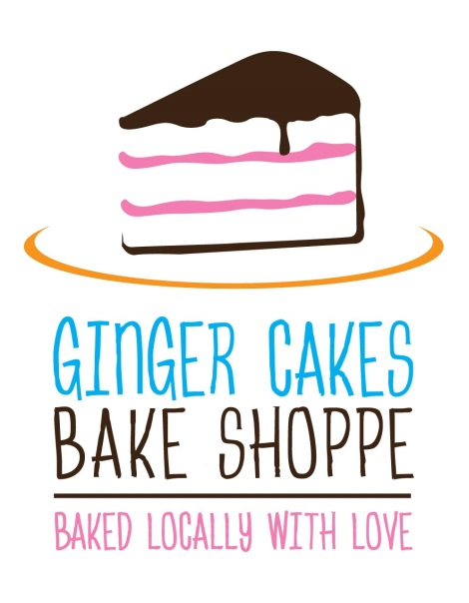
GINGER CAKES BAKE SHOPPE
Product Guide
Meg Cooksey & Bryan Lienesch (703) 475-1845 • gingercakesbakeshop@gmail.com
Gingercakesbakeshop.weebly.com
BREADS
Baguettes • Rustic Bread • Rustic Cheddar Bread • English Muffins • Yeast Rolls • Zucchini Bread
Peach Bread • Date Nut Bread • Rustic Farmer Bread • Focaccia with Rosemary • Olive Focaccia • Three Cheese Focaccia • Cinnamon Swirl Bagels • Cinnamon Raisin Bagels • Everything Bagels • Poppy Seed Bagels • Peanut Butter Cup Banana Bread • Apple Bread
COOKIES
Chocolate Chip • White Chocolate Macadamia • Snickerdoodles • Ginger Cakes •
Sugar Cookies • Coconut Macaroons • Peanut Blossoms • Chocolate Almond Biscotti • Cow Pies • Funfetti Biscotti • Monster Cookies • German Chocolate Macaroons • Shortbread • Cookies and Cream Cookies • Double Chocolate Biscotti • Pumpkin Spice Blossoms
SCONES
White Chocolate Cranberry • Cinnamon Brown Sugar • Cheddar Chive • Peach White Chocolate • Pumpkin • Oatmeal Peanut Butter Chocolate • Blueberry • Strawberry •Sweet Vanilla • Lemon Glazed Blueberry • Mixed Berry • Caramel Apple
DOUGHNUTS
Lemon Blueberry • Strawberry • Chocolate • Vanilla
Pops
Peach Pie • Apple Pie • Cherry Pie • Blueberry Pops • Rice Krispie Pops

OTHER GOODIES
Congo Bar • Brownies • Rice Krispie Treats • Energy Bites • Peppermint Bark• Peanut Butter Balls • Pumpkin Muffins • Chocolate Covered Pretzel Rods • Apple Hand Pies • Peach Hand Pies • Cherry Hand Pies • Blueberry Hand Pies
Have a treat that you love, but it’s not listed? Contact us; we are always trying new stuff!

